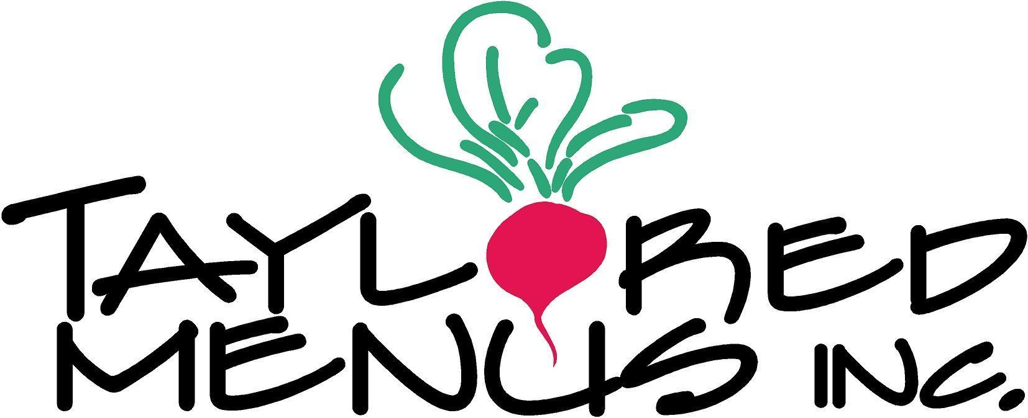

Super bowl LVII --- Sunday Feb. 12th, 2023
To Begin…
- Wings 12 pcs / 24 pcs CHOOSE: Buffalo, Maple Sriracha OR BBQ. $17, $31
- House Made potato skins: bacon, cheddar, scallion, sour cream- 6 pcs. $20
- Crudites of fresh veggies, blue cheese & hummus (serves 4- 6) $20
- Short rib bites wrapped in bacon dipped in BBQ sauce (12 per tray) $22
- Guacamole comes w/ tortilla chips- 16 oz $14
- Chicken Quesadillas served w/ salsa verde (20 pcs. Per tray) $26

Halftime
- Chili Beef or Turkey- CHOOSE. By the quart $16
- Our BBQ baby back ribs 12 & 24 pcs $27, $48
- 6 pack of sliders. Side L,T,O, pickles, ketchup, mustard, brioche buns & cheddar $27
- Creamy Mac & 3 cheese (side tray size serves 3-4) $17
- Garlic bread- Seeded semolina bread, fresh garlic, butter, Parmesan & Italian herbs $12

SALAD BOWLS serves 2-3 PEOPLE
- Arugula salad- slow grilled balsamic glazed red onions, parmesan & pine nuts. $17
- Caesar- homemade sourdough croutons, shaved parmesan & house vin. $17
- Noodle bowl w/ GF rice noodles, shitake, carrot, cucumber, spinach & spouts $17

Order by Noon on Thursday, February 9th
PICK up @ Café
Saturday 2/11, 9 AM TILL 2 PM OR
Sunday 2/12, 9 AM TILL 12 NOON

101 Castleton St. Pleasantville, NY
www.tayloredmenus.com (914) 741-5410

NO SUBSTITUTIONS OR SPECIAL ORDERS, PLEASE

